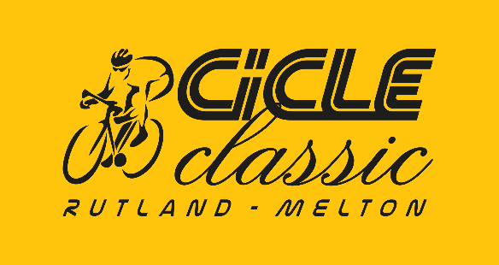 | Race sponsors 2018

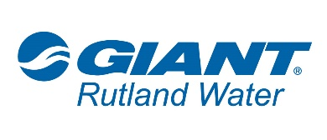 | Joint main sponsor of the race
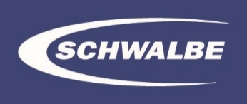 | Joint main sponsor of the race
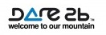 | Sponsor of the race officials clothing
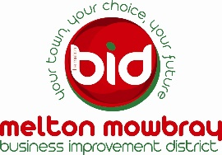 | Sponsor of the Finish area in Melton Town Centre.
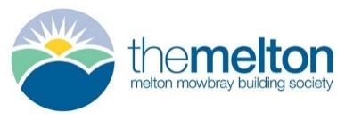 | Sponsor of the Team Competition within the race.
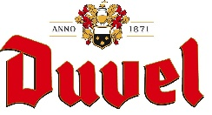 | Drinks hospitality sponsor of the race.
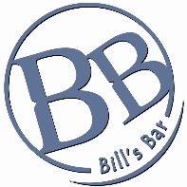 | Sponsor of the start area in Oakham Town Centre
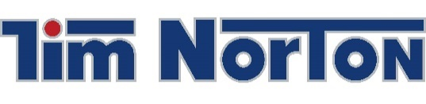 | Official principal vehicle sponsor and supplier to the race
 | Sponsor of the ‘King of the Bergs (Hills) ‘ competition within the race.
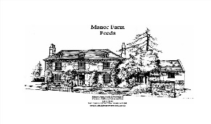 | Sponsor of the race o
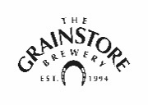 | Sponsor of the rider’s race numbers and ‘special’ your weight of beer award during the race.
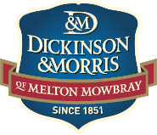 | Sponsor of the Melton Town Sprint award at the race’s first pass of the finish line.
Oakham Wines | Sponsor of the Oakham Town Sprint Award.
Pearce’s Jewellers | Sponsor of the Timing car.
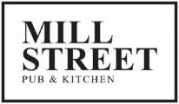 | Race day hospitality partner at Oakham start.
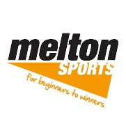 | Fan clothing distribution partner

